Assessor | J Baxter / L Finch
Date | 25.11.2025
Assessment Type | Review
Suburb | Bayswater
Street/  Near Street | King William Street near  Hill Street
COR File | 00373 94 F5
School/s | Bayswater Primary School  St Columba’s School
School Zone | No |  |  | Crossing Zone | No
Speed Limit | 40 Km/H (Permanent) |  |  | Method of Operation | Single
Number of Lanes | Vehicles |  | 2 | Other Lanes | Turning | No
Number of Lanes | Bus/Bike |  | 0 | Other Lanes | Turning | No
Road Width | 10.8 M |  |  | Other Lanes | Passing | No
Median/  Refuge/  Traffic Island | Yes  Width 1.3 M |  |  | Cut out | Yes  Width 2.4 M
Painted Lines | Yes | Median |  | Flashing Lights | On approach - Yes
Bends | N/A |  |  | Bends | Is line of sight affected?
Bends |  |  |  | Bends | N/A
Crest/ Incline/  Decline | Southeast  Of Crossing |  |  | Crest/ Incline | Is line of sight affected?
Crest/ Incline/  Decline |  |  |  | Crest/ Incline | No
Round About | Southeast  Of Crossing |  |  | Round About | Is line of sight affected?
Round About |  |  |  | Round About | No
Symbolic sign distance | Northwest  115 M |  |  | Symbolic sign distance | Southeast  85.2 M
Tactiles used | Pram Ramps |  | No | Tactiles Condition | N/A
Tactiles used | Centre  of road |  | No | Tactiles Condition
Sight  Distance | Northwest  80-120 M |  |  | Sight  Distance | Southeast  80-120 M
Bus Stops | Between 0-50 metres  on approach  of the crossing |  |  | Bus Stops | Between 0-50 metres  on departure  of the crossing
Bus Stops | No |  |  | Bus Stops | Yes (40m southeast)
Other Environmental Factors  (i.e vegetation, power poles and parking restrictions) | - Parking restrictions on approaches (signs/road markings) - Yes  - Trip Hazards - No  - Distance from stop line to ped line school side 6.7 M  - Distance from stop line to ped line non-school side 6.8 M  - Stop lines through Cycle and Bus lanes - No  - Painted lines condition - Worn  - Ped lines - Yes
Hazards Observed | - Compliance of parking restrictions YES  - Bus/Vehicle parking within 20 M on approach or 10 M on departure of crossing YES on both sides during crossing operation
Photo’s  (10 as per arrows) | 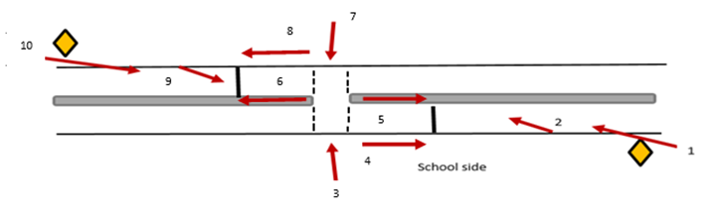
* Note – site assessment must be completed while crossing is operational

