Assessor | J Baxter / L Finch
Date | 25.11.2025
Assessment Type | Review
Suburb | Bayswater
Street/  Near Street | Whatley Crescent near  Leake Street
COR File | 00142 02 FV001
School/s | Bayswater Primary School  St Columba’s Primary School
School Zone | No |  |  | Crossing Zone | No
Speed Limit | 40 Km/H (permanent) |  |  | Method of Operation | Single
Number of Lanes | Vehicles |  | 2 | Other Lanes | Turning | No
Number of Lanes | Bus/Bike |  | 0 | Other Lanes | Turning | No
Road Width | 10.2 M |  |  | Other Lanes | Passing | No
Median/  Refuge/  Traffic Island | Yes  Width 2.1 M |  |  | Cut out | Yes  Width 3.5 M
Painted Lines | No |  |  | Flashing Lights | On approach - No
Bends | N/A |  |  | Bends | Is line of sight affected?
Bends |  |  |  | Bends | N/A
Incline/  Decline | East and West  Of Crossing |  |  | Crest/ Incline | Is line of sight affected?
Incline/  Decline |  |  |  | Crest/ Incline | No
Round About | N/A |  |  | Round About | Is line of sight affected?
Round About |  |  |  | Round About | N/A
Symbolic sign distance | East  97.6 M |  |  | Symbolic sign distance | West  92 M
Tactiles used | Pram Ramps |  | Yes | Tactiles Condition | Good
Tactiles used | Centre  of road |  | No | Tactiles Condition
Sight  Distance | East  80-120 M |  |  | Sight  Distance | West  80-120 M
Bus Stops | Between 0-50 metres  on approach  of the crossing |  |  | Bus Stops | Between 0-50 metres  on departure  of the crossing
Bus Stops | No |  |  | Bus Stops | No
Other Environmental Factors  (i.e vegetation, power poles and parking restrictions) | - Parking restrictions on approaches (signs/road markings) Yes  - Trip Hazards - No  - Distance from stop line to ped line school side - 6.3 M  - Distance from stop line to ped line non-school side - 6.7 M  - Stop lines through Cycle and Bus lanes - N/A  - Painted lines condition - Good  - Ped lines - Yes
Hazards Observed | - Compliance of parking restrictions N/A  - Bus/Vehicle parking within 20 M on approach or 10 M on departure of crossing NO
Photos  (10 as per arrows) | 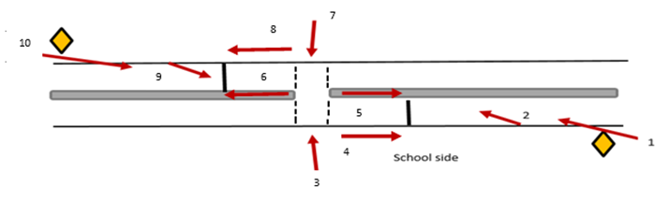
* Note – site assessment must be completed while crossing is operational

